Hi everyone,  Having adjusted to being in Level 2, things at school seem to be running smoothly and as well as can be expected with the extra hygiene considerations.  What a good turnout we had for the Playgroup visit to the school this morning. It is always very exciting to get together for some sharing and games. It is equally as wonderful to see family and community members turning up for assembly. It is an important aspect of a student's learning journey to share their passion and progress.  Tomorrow we are looking forward to planting Totara trees on the Anzac Walkway. The weather is not looking as good as we would like, so we are having lunch at school before going to plant the trees. We will have lunch at school at 12 o’clock. If you have some gardening gloves please bring those, as well as gumboots!  We have nearly completed designing a new bus schedule for the Mangapakeha/Manawa routes. A few more tweaks to look at and we will provide more detail next week on how it will look.  Are you amazing at sewing, cooking, woodwork, bushcraft, gardening or have some in depth knowledge you could share? Then we would love you to volunteer! We have a strong | belief that we all have something to offer and share. With this in mind we would like to introduce a new programme called ‘Electives’ next term. This is a programme where members of the community offer their expertise and skills to tutor the children for one or two hours per week. The programme would be run over several weeks and ‘tutors’ would work with the same, small group of children before a swap to another group. Students choose which skill they wish to learn (in other words which ‘elective’ they wish to do). So if you think you have something to offer, let us know and we can get the kids excited about their chosen ‘Electives’.  That’s all for now,  Simon  Acting Principal  Tinui School  Please remember if you have any questions, queries or concerns please contact Simon Couling at school on simonc@tinui.school.nz or Mieke Couling on miekec@tinui.school.nz  Eas

Important Dates  19/08 School Assembly, 2pm Parents Welcome  20/08 Anzac Walkway Planting Day  31/08 Teacher Only Day  10/09 Tinui School Cross Country  14/09 Epro 8  16/09 WaiCol Production - ‘All Shook Up’ - School Trip  22/09 Tinui School Production - ‘101 Heifers’  25/09 School Assembly 2pm, Term 3 Ends  12/10 Term 4 Starts  10/12 Overnight Camp  11/12 Beach Education  17/12 End of Year Function  18/12 End of term 4  8/2/21 Waitangi Day  9/2/21 Teacher Only Day  10/2/21 Term 1 Starts  Yummy are stoked to be able to run the sports gear promotion again this year!!  Winter is a great time to be eating Yummy apples, we have so many different varieties to choose from right now. We will be running a couple of school holiday competitions on our social platforms, so look out for those on both facebook and Instagram. And remember kids to eat lots of apples and collect the stickers for your school over the holidays and bring them in next term.  Please hand in any stickers or labels to me at the office and I will send them off. | Masterton Food Bank  Please note that on Friday is Masterton Schools Mufti Day (please see the flyer attached to the newsletter). If you can send a non-perishable food item along to school (to Rachel in the office) for the Masterton Food Bank I am sure there will be many very grateful Masterton families.  School Uniform  If your child/children requires a Tinui School uniform ie tracksuit, t-shirt and shorts please let Rachel know in the office and she will send one home.  Check out the school calendar for the whole year on the school website. Events will be added as they arise.  WANT COVID-19 INFO?  Check out the Ministry of Health  Facebook Page  MORE IMPORTANT STUFF 👇  PLEASE REVIEW OUR POLICIES ON SCHOOL DOCS!  Go to:  Our school docs site  Search for Tinui School and use  Username : tinui  Password : respect  Look for the red POLICY UNDER REVIEW tab. Please feel free to make comments on any of the policies under review. We need your input.
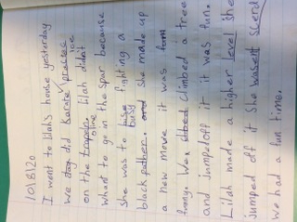  By Crystal M | By Lilah M  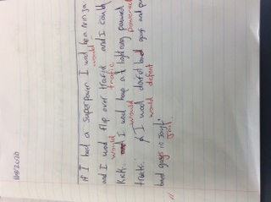  By Lockie B

Kids News It Up

Sport
Three weeks ago the East Coast hockey team faced M.I.S and lost 8 nil,
Then the following week the hockey team played Hadlow and lost 5 nil.
Three weeks ago the Masterton Red Star Rugby team faced Marest and they drew 6 nil.

Cross country
Every morning both classes go out to the field and do cross country training. The year 0-3 have to do 3 laps and the rest of us have to do 4 laps.
So make sure to be at the Tinui cross country on the 10th of september 2020 to see The Tinui runners win.

STEAM
Steam this week has been very exciting with all ages getting in and having a go at building and and using the droid robots. Lockie Brown says it was very interesting and fun but found it difficult. His favourite part was building but overall it was a good challenge.

Our backyard
This term our focus is on Our Backyard so that means we are doing lots of Social studies and outdoor stuff to do with what nature does. On the 20th of August Tinui school are going up Tinui Anzac walkway to plant native trees to help the environment.

Funsticks
On Thursday the junior classroom has funsticks at the turf and love getting up there and giving it a go.
Marisa says it is very fun and she loves dribbling the ball.
By Jane S & Madi M

