Kia ora koutou Tinui whānau and friends!  It’s been a super busy term with lots happening.  Our Science day with Thom from Victoria University was a huge success with all students deeply engaged with the experiments that Thom demonstrated and the hands on experiments students conducted themselves. The liquid nitrogen rockets and elephant toothpaste were huge hits with all! (Even the adults !)  We had a great afternoon catching up with our school families at our whānau afternoon last Friday. It was great to see so many of our families mixing and mingling and cooling off in the pool.  The Rural Schools Swimming went well with several of our students qualifying for the Masterton schools event being held next Wednesday 4th. We will send home information about the Masterton Schools event with students who have qualified. The cricket and movement sessions at Queen Elizabeth Park were great fun and we will be working with Barry and the Kia Hakinakina team again this year developing the delivering of physical education lessons and deepening teacher and student understanding of the importance of basic movement skills and transferring them into a number of different sports.  The refurbishment of Room 2 is now progressing well with the lining going on the walls and the wet area cabinetry arriving. Over the next couple of weeks things will really ramp up and we hope to have the refurbishment finished well before the end of term. We have the Ki O Rahi tournament at Riversdale beach next Friday for most of our Room 4 students so look out for a notice coming home about that and we will be trialling both a paper and electronic permission from Skool Loop for that event. We have noticed that some parents are using Skool Loop to report absences and that is fantastic as we are sent an email notification. Please do make sure that you do contact the school when your child is absent as we have had a couple of instances where a child is absent and we have not heard from the family. For health and safety reasons we must account for all students each day so please keep us up to speed and eliminate the need for us to try and track absent students. Thanks to all families who already do this.  Have a great rest of the week and weekend!  If you need to contact me please do so at school or on principal@tinui.school.nz  Nga mihi  Richard Lennox | WEEK RESPECT AWARD RECIPIENTS  Each week we give a RESPECT award to students who have been demonstrating and role modelling our Tinui School RESPECT values.  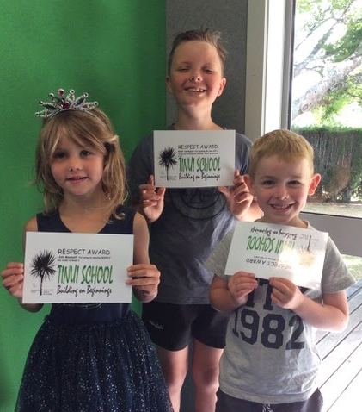  Last week’s RESPECT certificates went to Lilah M for being an amazing RESPECT role model in Room 3.  West V for beginning the year with a Caring and Enthusiastic attitude. What an awesome start! And also wishing Mason L, Bryn D and Thomas H (the latter two both absent) a very warm welcome to Tinui School.

Important Dates  4/3 Masterton Schools Swimming  5/3 Scooter Fun with Constable Julie  6/3 Ki O Rahi at Riversdale Beach  18/3 Wairarapa Swimming Champs  26/3 Year 7 immunisations  9/4 End of Term 1  Check out the school calendar for the whole year on the school website. Events will be added as they arise.  MORE IMPORTANT STUFF 👇  PLEASE REVIEW OUR POLICIES ON SCHOOL DOCS!  Go to: Our school docs site www.schooldocs.co.nz  Search for Tinui School and use  Username : tinui  Password : respect  Look for the red POLICY UNDER REVIEW tab. Please feel free to make comments on any of the policies under review. We need your input.  This term’s policies under review is:  Alcohol, Drugs and other Harmful Substances | PHOTO GALLERY  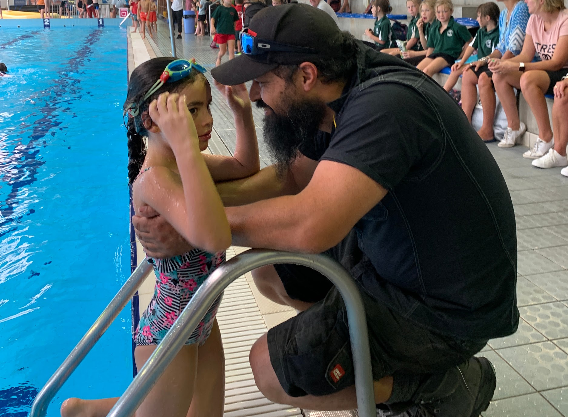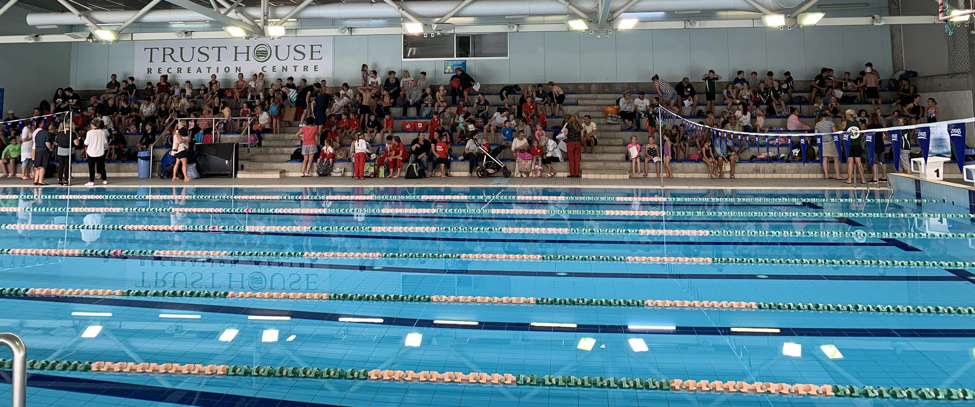

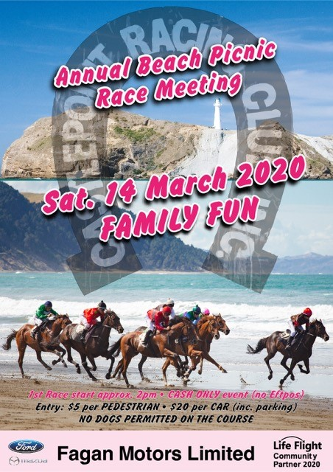  Breadcraft Kids Triathlon Series  Triathlon Series, started Monday 17th February.  Register Now online at www.wmsc.org.nz to get all 3 races for $10.50.  Entry on the day will be $10 PER RACE.  Any queries ring Judy Brown 0276815800 or 3787867  Run by the Wairarapa Multisports club  DATES: Monday 2nd March 2020  3 Pre-registration events where club members will help with registration: (cash only | Kids Go Free at Staglands on Children’s Day  Staglands Wildlife Reserve will be celebrating Children’s Day on Sunday 1st March by offering FREE ENTRY into The Reserve for ALL CHILDREN.  In addition to their usual attractions visitors can enjoy free off-road tractor-trailer rides. So if you are looking for a fun Children’s day outing for the whole family; meet at Staglands and Connect with Nature on Sunday 1st March.  *Offer is not available with any other offer. Children (0-16 years) must be accompanied by paying adult.  For more information visit www.staglands.co.nz.  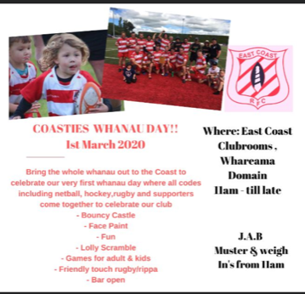

FREE CPR LESSONS FOR THE TINUI COMMUNITY
On average, four people a week from the greater Wellington and Wairarapa region fall victim to sudden cardiac arrest at home, at work or on the street. Their best chance of survival is literally in the hands of someone close by to commence lifesaving skills. In conjunction with the Lloyd Morrison Foundation we want to make Wellington and the Wairarapa a world leader for people surviving a Sudden Cardiac Arrest by teaching our wider community the fundamentals of CPR and community defibrillation.
The immediate actions of family or members of the public have a significant impact on whether a person survives; by performing CPR and using a defibrillator until emergency services arrive and can take over. Our ultimate aim is that no matter whether rural or urban someone within a 5 km radius will have the knowledge to initiate CPR and use an AED.
We would love to offer the Tinui community the opportunity to come to a free CPR training session, taught by our local Wairarapa Paramedics. Training sessions can be tailored to the needs of the group, and can involve between 5 and 20 people at a time. The sessions take a minimum of 30 minutes to complete.
If you are interested in attending a free CPR training session please email Rachel in the school office to register your interest on office@tinui.school.nz

